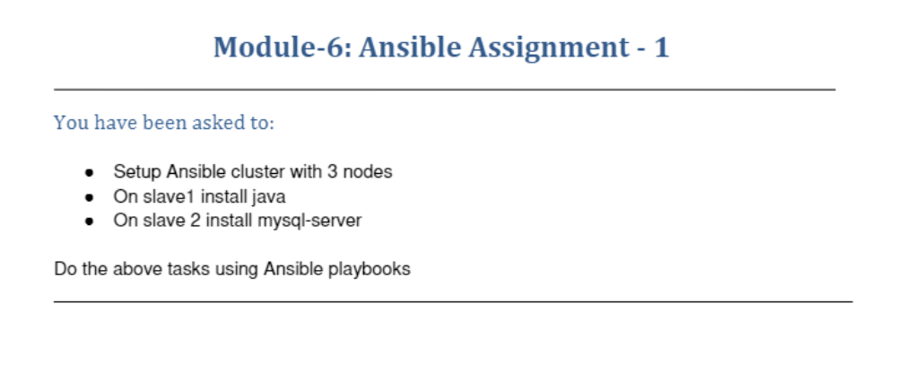
ubuntu@ip-172-31-11-54:~$ vi /etc/ansible/hosts
ubuntu@ip-172-31-11-54:~$ ubuntu@ip-172-31-11-54:~$
ubuntu@ip-172-31-11-54:~$ ansible --version
ansible [core 2.11.6]
config file = /etc/ansible/ansible.cfg
configured module search path = ['/home/ubuntu/.ansible/plugins/modules', '/usr/share/ansible/plugins/modules']
ansible python module location = /usr/lib/python3/dist-packages/ansible
ansible collection location = /home/ubuntu/.ansible/collections:/usr/share/ansible/collections
executable location = /usr/bin/ansible
python version = 3.8.10 (default, Sep 28 2021, 16:10:42) [GCC 9.3.0]
jinja version = 2.10.1
libyaml = True
ubuntu@ip-172-31-11-54:~$ cd .ssh
ubuntu@ip-172-31-11-54:~/.ssh$ ssh ubuntu@18.191.106.57
Welcome to Ubuntu 20.04.2 LTS (GNU/Linux 5.4.0-1045-aws x86_64)

* Documentation: https://help.ubuntu.com
* Management: https://landscape.canonical.com
* Support: https://ubuntu.com/advantage

System information as of Wed Oct 27 00:06:07 UTC 2021

System load: 0.0 Processes: 107
Usage of /: 9.1% of 19.32GB Users logged in: 1
Memory usage: 23% IPv4 address for eth0: 172.31.26.3
Swap usage: 0%

* Ubuntu Pro delivers the most comprehensive open source security and
compliance features.

https://ubuntu.com/aws/pro

136 updates can be applied immediately.
71 of these updates are standard security updates.
To see these additional updates run: apt list --upgradable

Last login: Wed Oct 27 00:00:10 2021 from 49.37.172.148
To run a command as administrator (user "root"), use "sudo <command>".
See "man sudo_root" for details.

ubuntu@ip-172-31-26-3:~$ exit
logout
Connection to 18.191.106.57 closed.
ubuntu@ip-172-31-11-54:~/.ssh$ sudo nano /etc/ansible/hosts
ubuntu@ip-172-31-11-54:~/.ssh$ ansible -m ping all
slave1 | SUCCESS => {
"ansible_facts": {
"discovered_interpreter_python": "/usr/bin/python3"
},
"changed": false,
"ping": "pong"
}
ubuntu@ip-172-31-11-54:~$ ls
ansible
ubuntu@ip-172-31-11-54:~$ cd ansible/
ubuntu@ip-172-31-11-54:~/ansible$ ls
hosts myplaybook.yaml
ubuntu@ip-172-31-11-54:~/ansible$ vi myplaybook.yaml
ubuntu@ip-172-31-11-54:~/ansible$ sudo apt update
Hit:1 http://us-east-2.ec2.archive.ubuntu.com/ubuntu focal InRelease
Get:2 http://us-east-2.ec2.archive.ubuntu.com/ubuntu focal-updates InRelease [114 kB]
Get:3 http://us-east-2.ec2.archive.ubuntu.com/ubuntu focal-backports InRelease [101 kB]
Get:4 http://security.ubuntu.com/ubuntu focal-security InRelease [114 kB]
Hit:5 http://ppa.launchpad.net/ansible/ansible/ubuntu focal InRelease
Get:6 http://us-east-2.ec2.archive.ubuntu.com/ubuntu focal-updates/main amd64 Packages [1297 kB]
Get:7 http://us-east-2.ec2.archive.ubuntu.com/ubuntu focal-updates/main amd64 c-n-f Metadata [14.4 kB]
Get:8 http://us-east-2.ec2.archive.ubuntu.com/ubuntu focal-updates/restricted amd64 Packages [524 kB]
Get:9 http://us-east-2.ec2.archive.ubuntu.com/ubuntu focal-updates/universe amd64 Packages [867 kB]
Get:10 http://us-east-2.ec2.archive.ubuntu.com/ubuntu focal-updates/universe Translation-en [186 kB]
Get:11 http://us-east-2.ec2.archive.ubuntu.com/ubuntu focal-updates/universe amd64 c-n-f Metadata [19.3 kB]
Get:12 http://security.ubuntu.com/ubuntu focal-security/main amd64 Packages [949 kB]
Get:13 http://security.ubuntu.com/ubuntu focal-security/main Translation-en [178 kB]
Get:14 http://security.ubuntu.com/ubuntu focal-security/restricted amd64 Packages [483 kB]
Get:15 http://security.ubuntu.com/ubuntu focal-security/restricted Translation-en [69.2 kB]
Fetched 4915 kB in 1s (3792 kB/s)
Reading package lists... Done
Building dependency tree
Reading state information... Done
62 packages can be upgraded. Run 'apt list --upgradable' to see them.
ubuntu@ip-172-31-11-54:~/ansible$ vi myplaybook.yaml
ubuntu@ip-172-31-11-54:~/ansible$ ansible-playbook myplaybook.yaml

PLAY [play1] *************************************************************************************************************

TASK [Gathering Facts] ***************************************************************************************************
ok: [slave1]

TASK [install java] ******************************************************************************************************
changed: [slave1]

PLAY RECAP ***************************************************************************************************************
slave1 : ok=2 changed=1 unreachable=0 failed=0 skipped=0 rescued=0 ignored=0
ubuntu@ip-172-31-26-3:~$ java --version
openjdk 11.0.11 2021-04-20
OpenJDK Runtime Environment (build 11.0.11+9-Ubuntu-0ubuntu2.20.04)
OpenJDK 64-Bit Server VM (build 11.0.11+9-Ubuntu-0ubuntu2.20.04, mixed mode, sharing)

ubuntu@ip-172-31-11-54:~$ sudo vi /etc/ansible/hosts
ubuntu@ip-172-31-11-54:~$ ansible -m ping all
[DEPRECATION WARNING]: Distribution Ubuntu 20.04 on host slave2 should use /usr/bin/python3, but is using /usr/bin/python
for backward compatibility with prior Ansible releases. A future Ansible release will default to using the discovered
platform python for this host. See https://docs.ansible.com/ansible-
core/2.11/reference_appendices/interpreter_discovery.html for more information. This feature will be removed in version
2.12. Deprecation warnings can be disabled by setting deprecation_warnings=False in ansible.cfg.
slave2 | SUCCESS => {
"ansible_facts": {
"discovered_interpreter_python": "/usr/bin/python"
},
"changed": false,
"ping": "pong"
}
slave1 | SUCCESS => {
"ansible_facts": {
"discovered_interpreter_python": "/usr/bin/python3"
},
"changed": false,
"ping": "pong"
}
ubuntu@ip-172-31-11-54:~$ cd ansible/
ubuntu@ip-172-31-11-54:~/ansible$ vi myplaybook.yaml
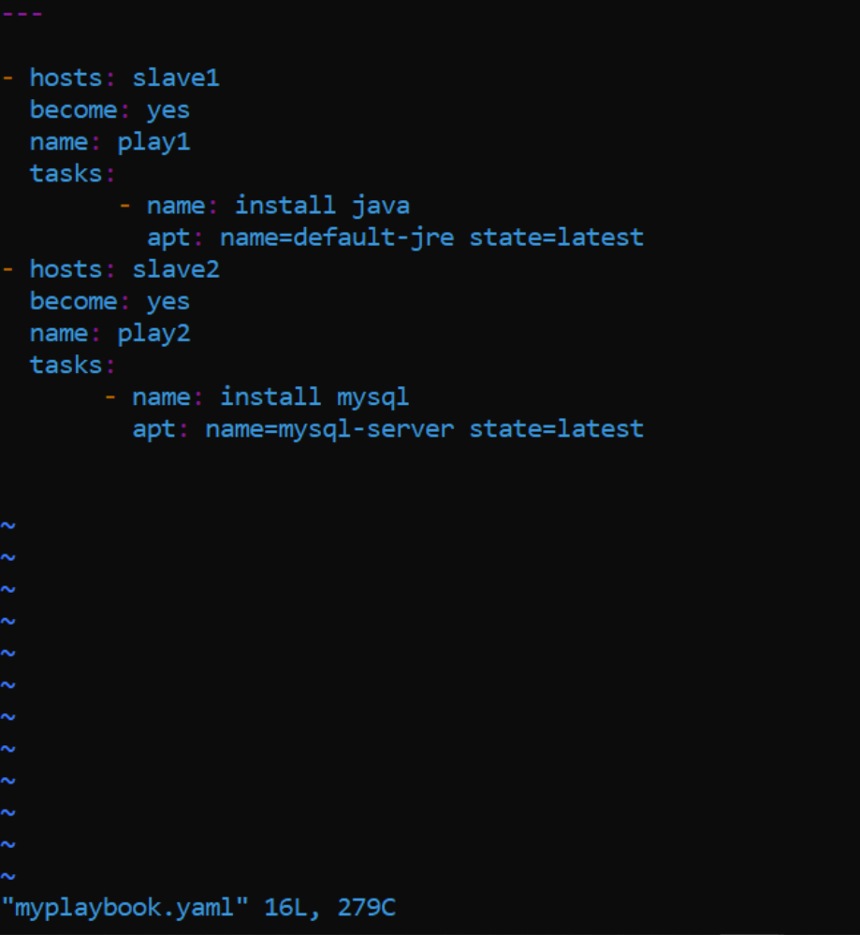
ubuntu@ip-172-31-11-54:~/ansible$ ansible-playbook myplaybook.yaml

PLAY [play1] *************************************************************************************************************

TASK [Gathering Facts] ***************************************************************************************************
ok: [slave1]

TASK [install java] ******************************************************************************************************
ok: [slave1]

PLAY [play2] *************************************************************************************************************

TASK [Gathering Facts] ***************************************************************************************************
[DEPRECATION WARNING]: Distribution Ubuntu 20.04 on host slave2 should use /usr/bin/python3, but is using /usr/bin/python
for backward compatibility with prior Ansible releases. A future Ansible release will default to using the discovered
platform python for this host. See https://docs.ansible.com/ansible-
core/2.11/reference_appendices/interpreter_discovery.html for more information. This feature will be removed in version
2.12. Deprecation warnings can be disabled by setting deprecation_warnings=False in ansible.cfg.
ok: [slave2]
TASK [install mysql] *****************************************************************************************************
changed: [slave2]
PLAY RECAP ***************************************************************************************************************
slave1 : ok=2 changed=0 unreachable=0 failed=0 skipped=0 rescued=0 ignored=0
slave2 : ok=2 changed=1 unreachable=0 failed=0 skipped=0 rescued=0 ignored=0
ubuntu@ip-172-31-18-250:~$ mysql --version
mysql Ver 8.0.27-0ubuntu0.20.04.1 for Linux on x86_64 ((Ubuntu))

